Day of the Dead Extra Credit Project
Day of the Dead is a holiday celebrated in Mexico and other parts of the world on November 2. It is a holiday that remembers and celebrates the lives of ancestors and relatives who have passed away. There are a lot of common myths and misconceptions of Day of the Dead (see below). Two common things that are found during the Day of the Dead celebration in Mexico are Pan de Muertos and Calaveras de Azúcar. If you wish, you may follow the recipes provided and bring one of these into class on October 31 OR November 3 to share. Students who do this will receive 10 points of extra credit. If you bring in store bought bread of the dead or sugar skulls you will receive 5 points of extra credit.
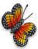 | El Dia de los Muertos is not the Mexican version of Halloween. Mexicans have celebrated the Day of the Dead since the year 1800 B.C.
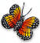 | It is not scary or morbid. There are no pictures or images of dead people, ghosts, witches, or the devil.
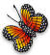 | The Day of the Dead is not a cult. This ritual has nothing to do with cults. It is a Catholic Christian ritual intermixed with folk culture. Going to mass is an essential aspect of this celebration.
 | It doesn’t honor death, but our dead relatives. We welcome the opportunity to reflect upon our lives, our heritage, our ancestors and the meaning and purpose of our own existence.
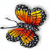 | Altars or ofrendas are not for worshiping but for offering our love and remembering our departed family members.
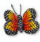 | It is not a sad ritual. It’s a day of happiness because we will be remembering our loved ones. Although when in the graveyard, people assume an introspective attitude.
 | The Day of the Dead is about Love not Fear.
 | It is not a “strange” ritual. It is very similar to going to a grave and leaving flowers or stuffed animals, lighting a candle to remember the deceased.
 | It is not a careless or fearless confrontation of death. It is a moment to reflect upon one’s life and the cycle of life and death.

Calaveras de azucár/Sugar Skulls: Sugar art was brought to the New World by Italian missionaries in the 17th century. The first Church mention of sugar art was from Palermo at Easter time when little sugar lambs and angels were made to adorn the side altars in the Catholic Church. Mexico, abundant in sugar production and too poor to buy fancy imported European church decorations, learned quickly from the friars how to make sugar art for their religious festivals. Clay molded sugar figures of angels, sheep and sugar skulls go back to the Colonial Period 18th century. Sugar skulls represented a departed soul, had the name written on the forehead and was placed on the home ofrenda or gravestone to honor the return of a particular spirit. Sugar skull art reflects the folk art style of big happy smiles, colorful icing and sparkly tin and glittery adornments. Sugar skulls are labor intensive and made in very small batches in the homes of sugar skull makers. These wonderful artisans are disappearing as fabricated and imported candy skulls take their place.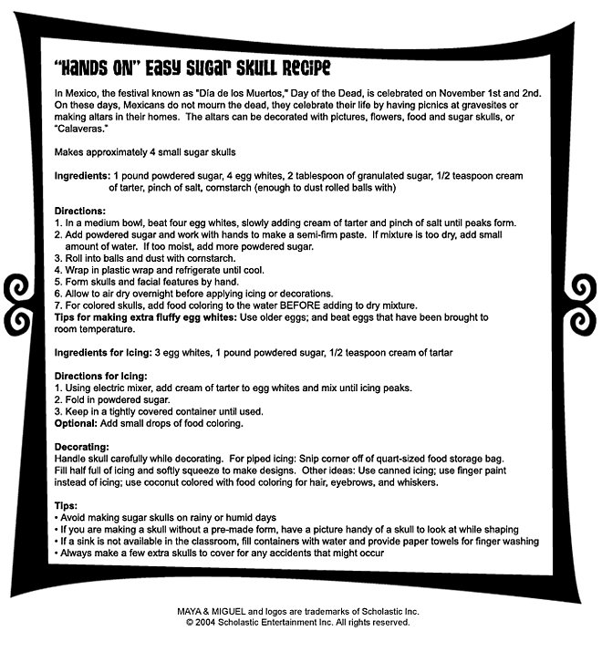

The pan de muertos (Spanish for Bread of the dead) (also called pan de los muertos) is a type of bread traditionally baked in Mexico during the weeks leading up to the Día de los Muertos, which is celebrated on November 1 and 2. It is a sweetened soft bread shaped like a bun, often decorated with bone-like pieces. Pan de muertos is eaten on Día de los Muertos, at the gravesite or altar of the deceased. In some regions it is eaten for months before the official celebration of Dia de los Muertos. In Oaxaca, pan de muertos is the same bread that is usually baked, with the addition of decorations. As part of the celebration, loved ones eat pan de muertos as well as the relative's favorite foods. The bones represent the lost one (difuntos or difuntas) and there is normally a baked tear drop on the bread to represent sorrow. The bones are represented in a circle to portray the circle of life.The classic recipe for Pan de Muertos is a simple sweet bread recipe, often with the addition of anise seeds, and other times flavored with orange flower water. Other variations are made depending on the region or the baker.

Ingredients
- 1/4 cup margarine
- 1/4 cup milk
- 1/4 cup warm water (110 degrees F/45 degrees C)
- 3 cups all-purpose flour
- 1 1/4 teaspoons active dry yeast
- 1/2 teaspoon salt
- 2 teaspoons anise seed
- 1/4 cup white sugar
- 2 eggs, beaten
- 2 teaspoons orange zest
- 1/4 cup white sugar
- 1/4 cup orange juice
- 1 tablespoon orange zest
- 2 tablespoons white sugar

Directions
- Heat the milk and the butter together in a medium saucepan, until the butter melts. Remove from the heat and add them warm water. The mixture should be around 110 degrees F (43 degrees C).
- In a large bowl combine 1 cup of the flour, yeast, salt, anise seed and 1/4 cup of the sugar. Beat in the warm milk mixture then add the eggs and orange zest and beat until well combined. Stir in 1/2 cup of flour and continue adding more flour until the dough is soft.
- Turn the dough out onto a lightly floured surface and knead until smooth and elastic.
- Place the dough into a lightly greased bowl cover with plastic wrap and let rise in a warm place until doubled in size. This will take about 1 to 2 hours. Punch the dough down and shape it into a large round loaf with a round knob on top. Place dough onto a baking sheet, loosely cover with plastic wrap and let rise in a warm place for about 1 hour or until just about doubled in size.
- Bake in a preheated 350 degrees F (175 degrees C) oven for about 35 to 45 minutes. Remove from oven let cool slightly then brush with glaze.
- To make glaze: In a small saucepan combine the 1/4 cup sugar, orange juice and orange zest. Bring to a boil over medium heat and boil for 2 minutes. Brush over top of bread while still warm. Sprinkle glazed bread with white sugar.

